

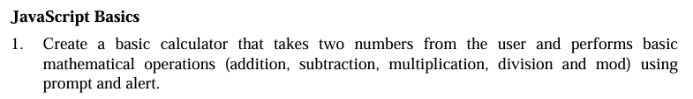

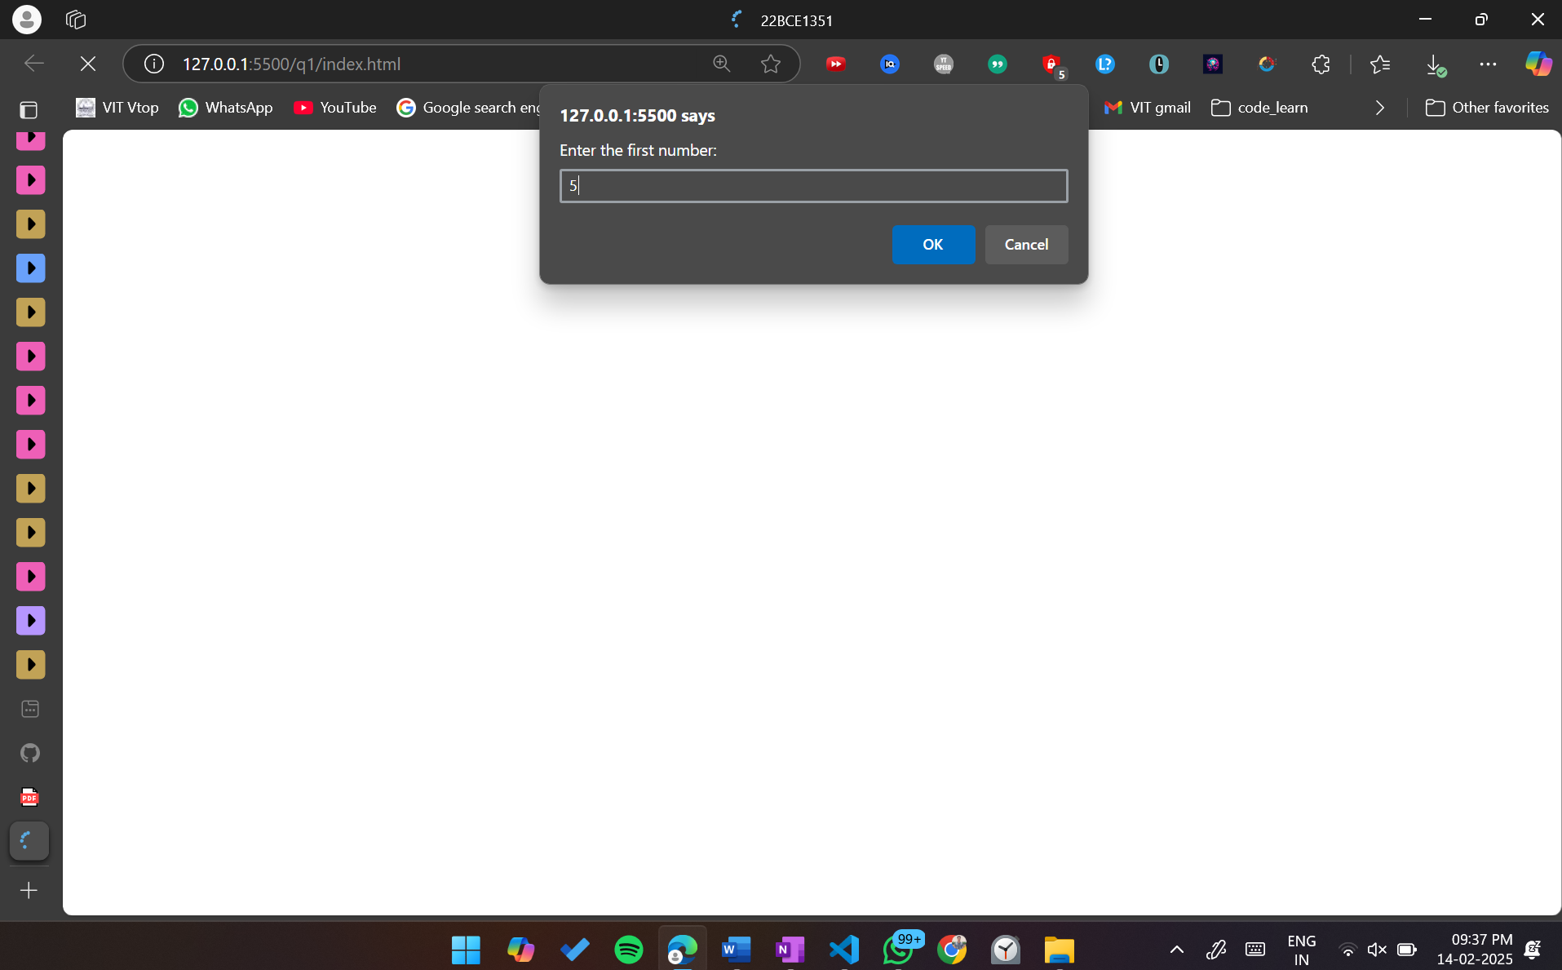

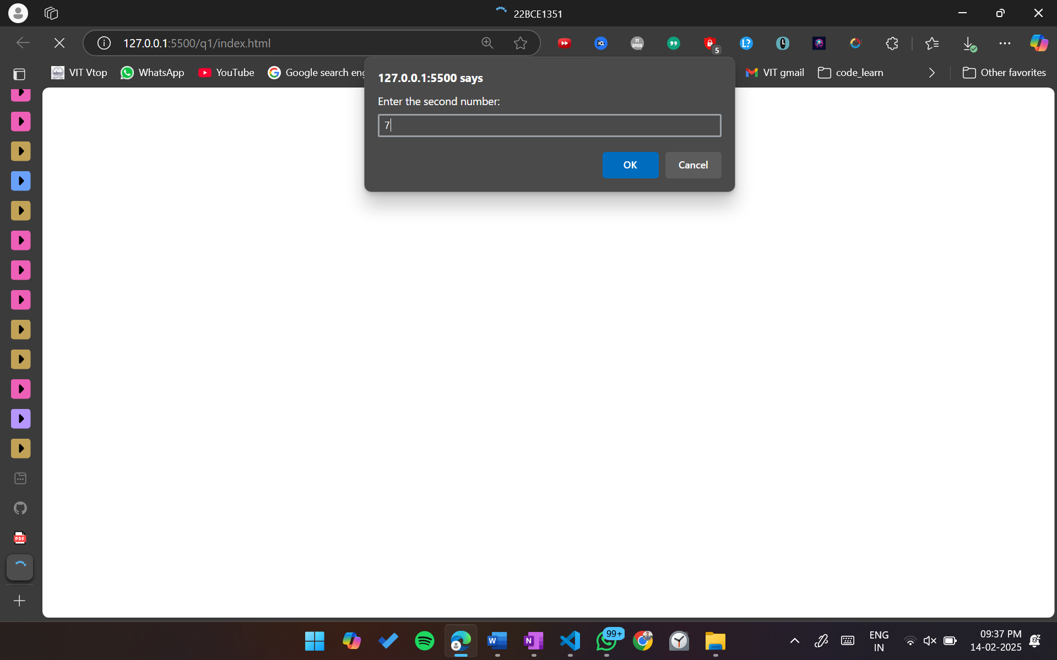

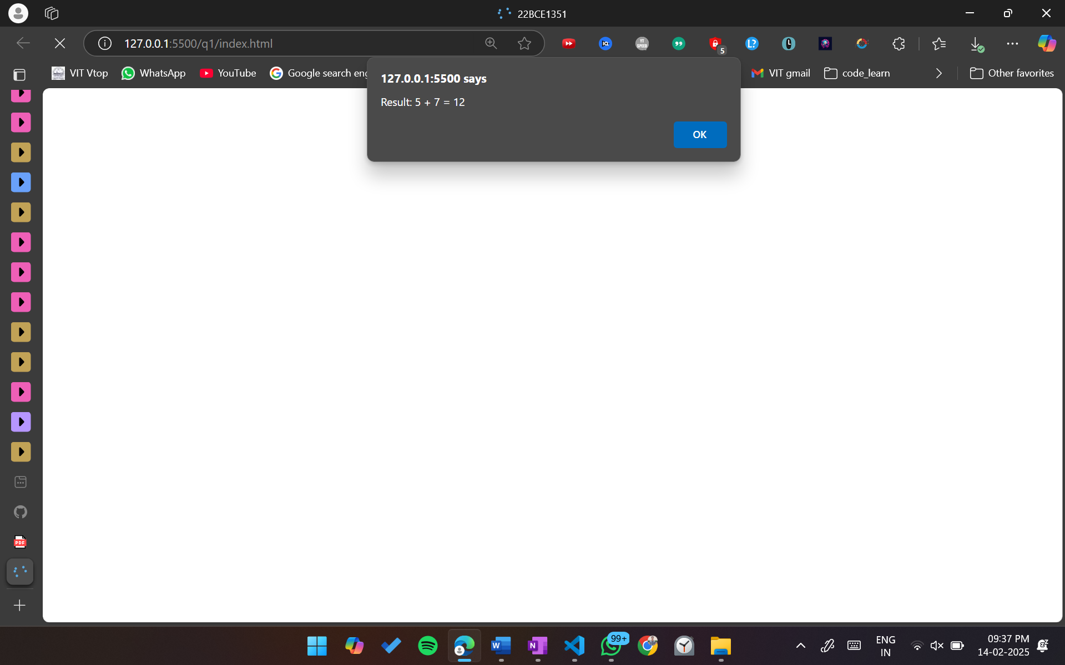

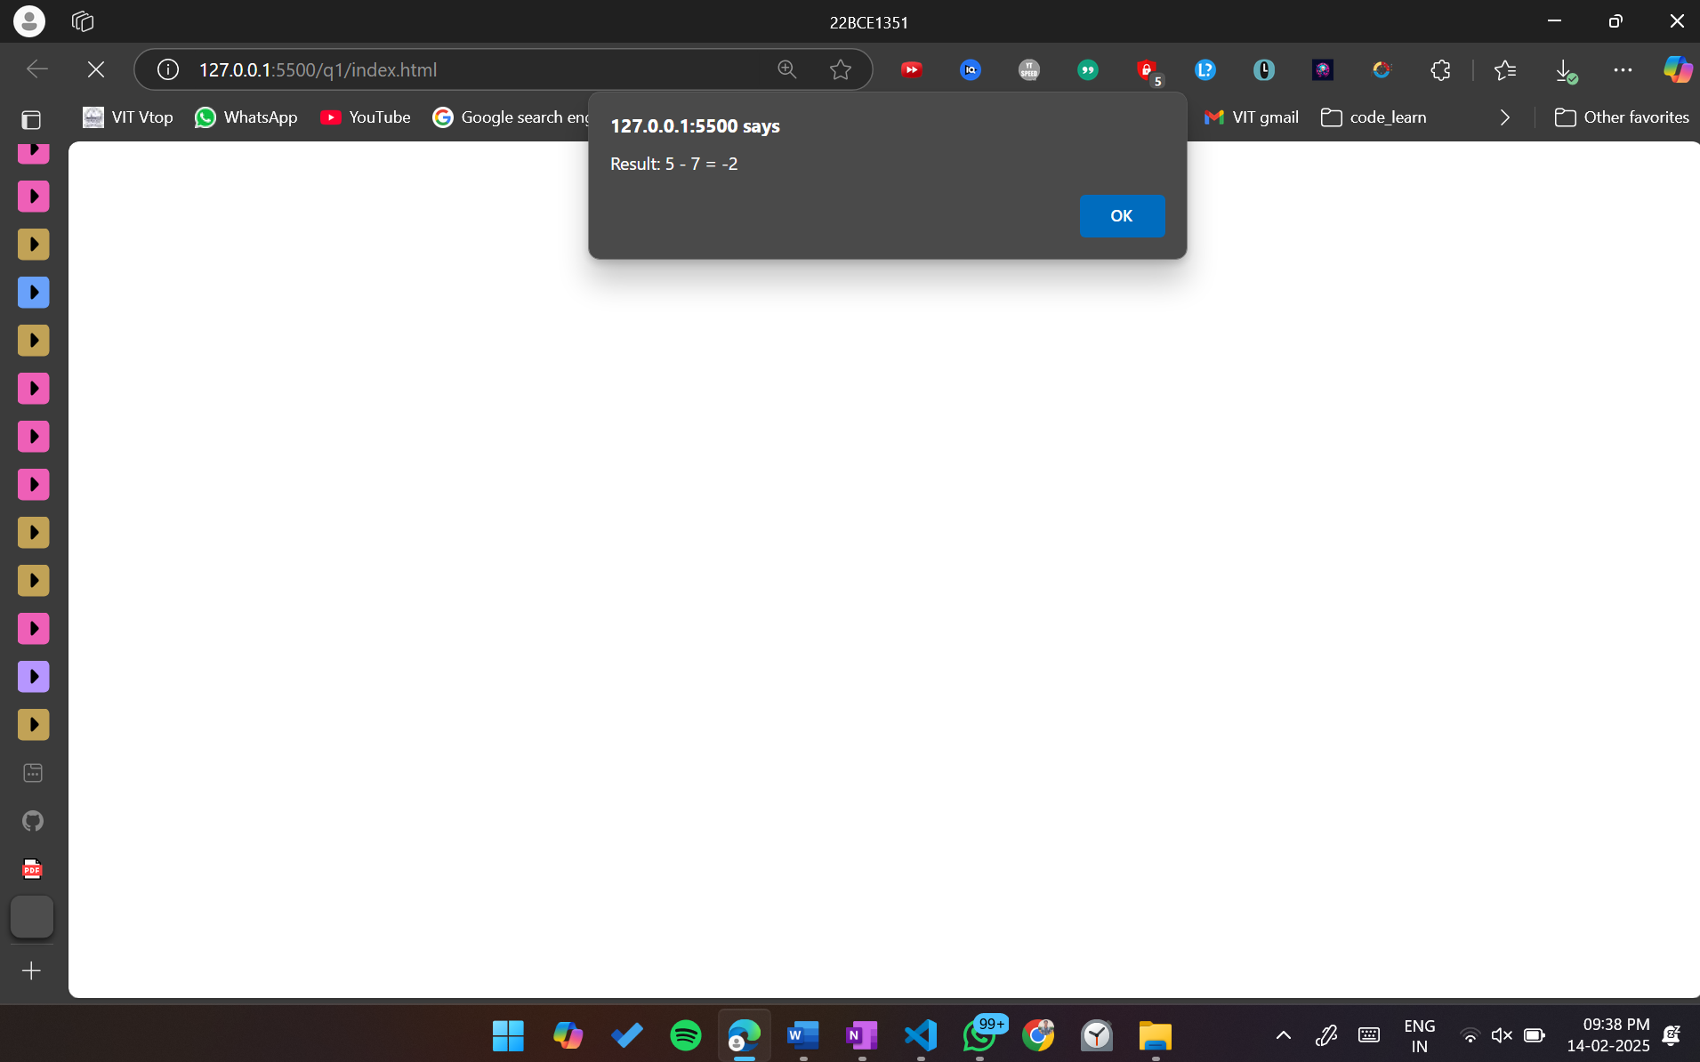

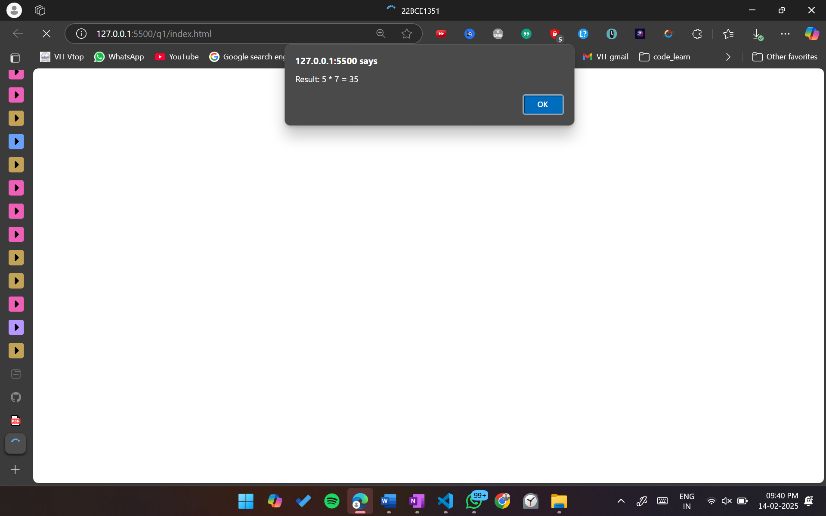

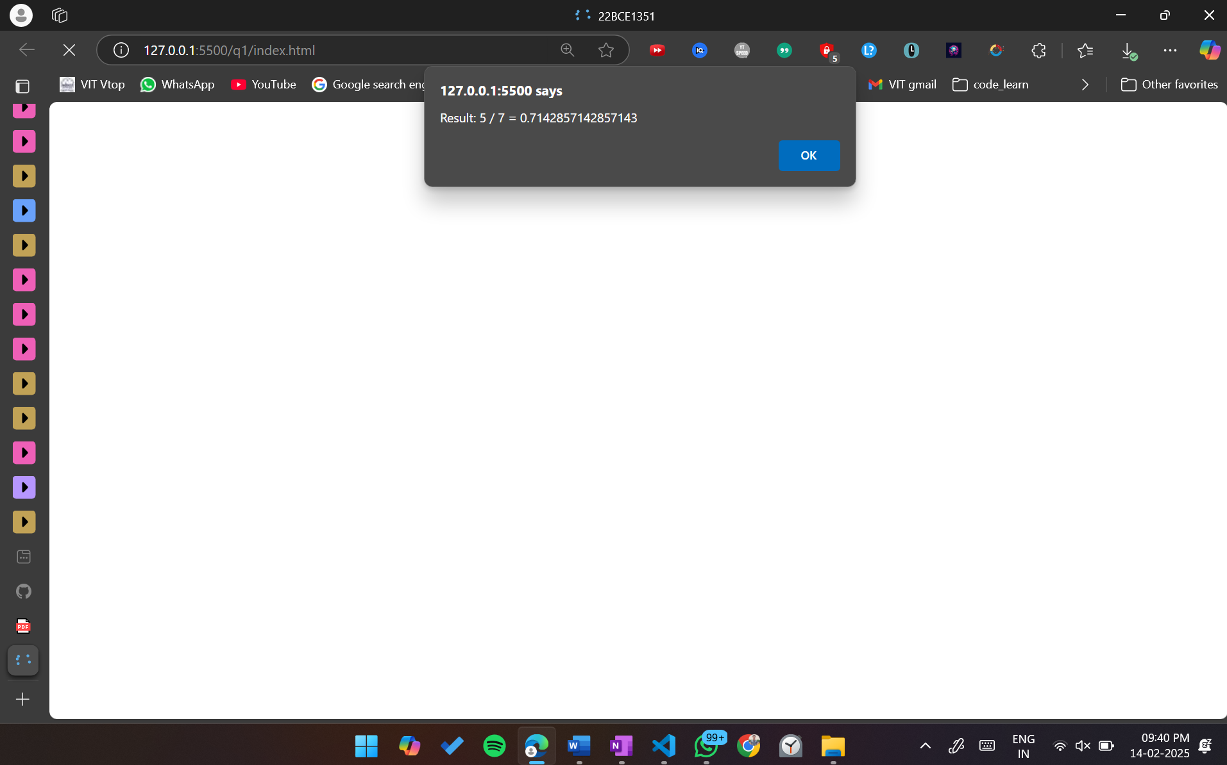

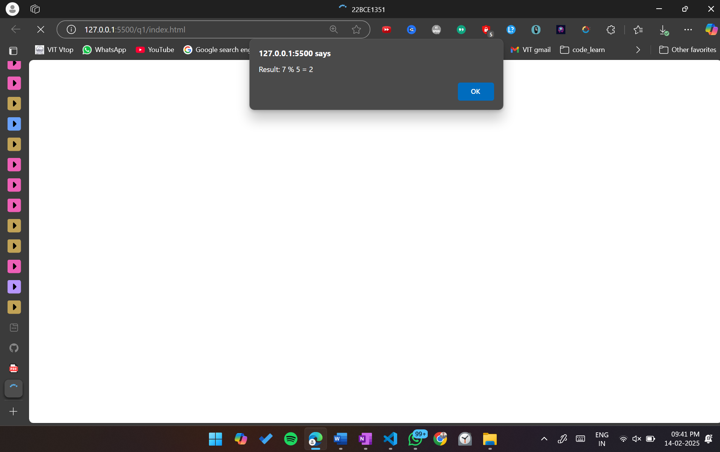

<!DOCTYPE html>

<html lang="en">

<head>

    <meta charset="UTF-8">

    <meta name="viewport" content="width=device-width, initial-scale=1.0">

    <title>22BCE1351</title>

</head>

<body>

    <script>

        function calculator() {

            let num1 = parseFloat(prompt("Enter the first number:"));

            let num2 = parseFloat(prompt("Enter the second number:"));

            let operation = prompt("Choose an operation: +, -, \*, /, %");

            let result;

            switch (operation) {

                case "+":

                    result = num1 + num2;

                    break;

                case "-":

                    result = num1 - num2;

                    break;

                case "\*":

                    result = num1 \* num2;

                    break;

                case "/":

                    if (num2 !== 0) {

                        result = num1 / num2;

                    } else {

                        alert("Error: Division by zero is not allowed!");

                        return;

                    }

                    break;

                case "%":

                    result = num1 % num2;

                    break;

                default:

                    alert("Invalid operation! Please enter +, -, \*, /, or %.");

                    return;

            }

            alert(`Result: ${num1} ${operation} ${num2} = ${result}`);

        }

        calculator();

    </script>

</body>

</html>



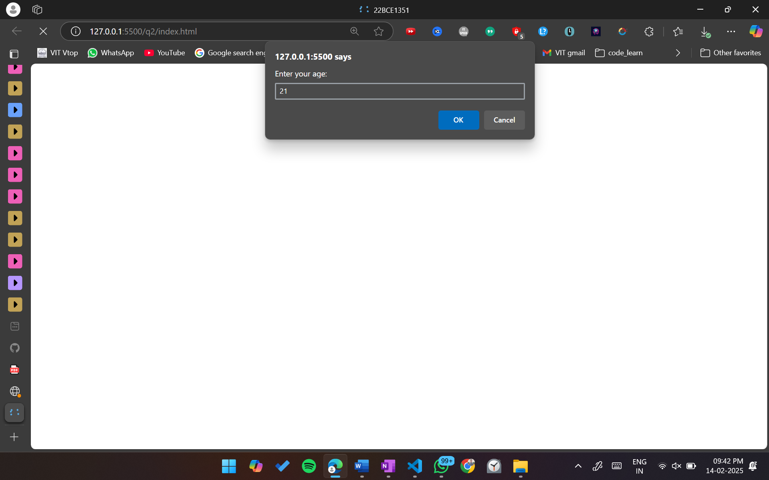

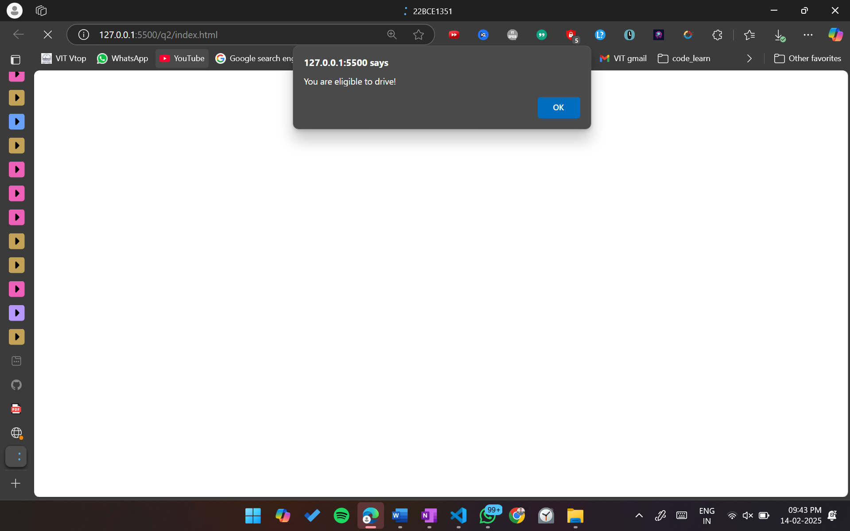

<!DOCTYPE html>

<html lang="en">

<head>

    <meta charset="UTF-8">

    <meta name="viewport" content="width=device-width, initial-scale=1.0">

    <title>22BCE1351</title>

</head>

<body>

    <script>

        function checkEligibility() {

            let age = parseInt(prompt("Enter your age:"));

            if (age <= 0) {

                alert("Please enter a valid age!");

            } else if (age >= 18) {

                alert("You are eligible to drive!");

            } else {

                alert("Sorry, you are not eligible to drive yet.");

            }

        }

        checkEligibility();

    </script>

</body>

</html>



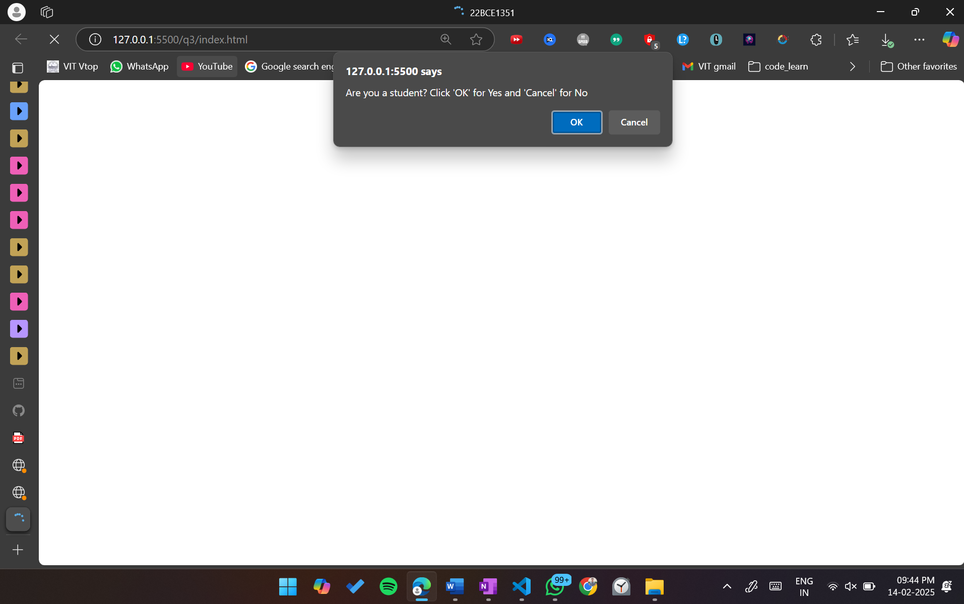

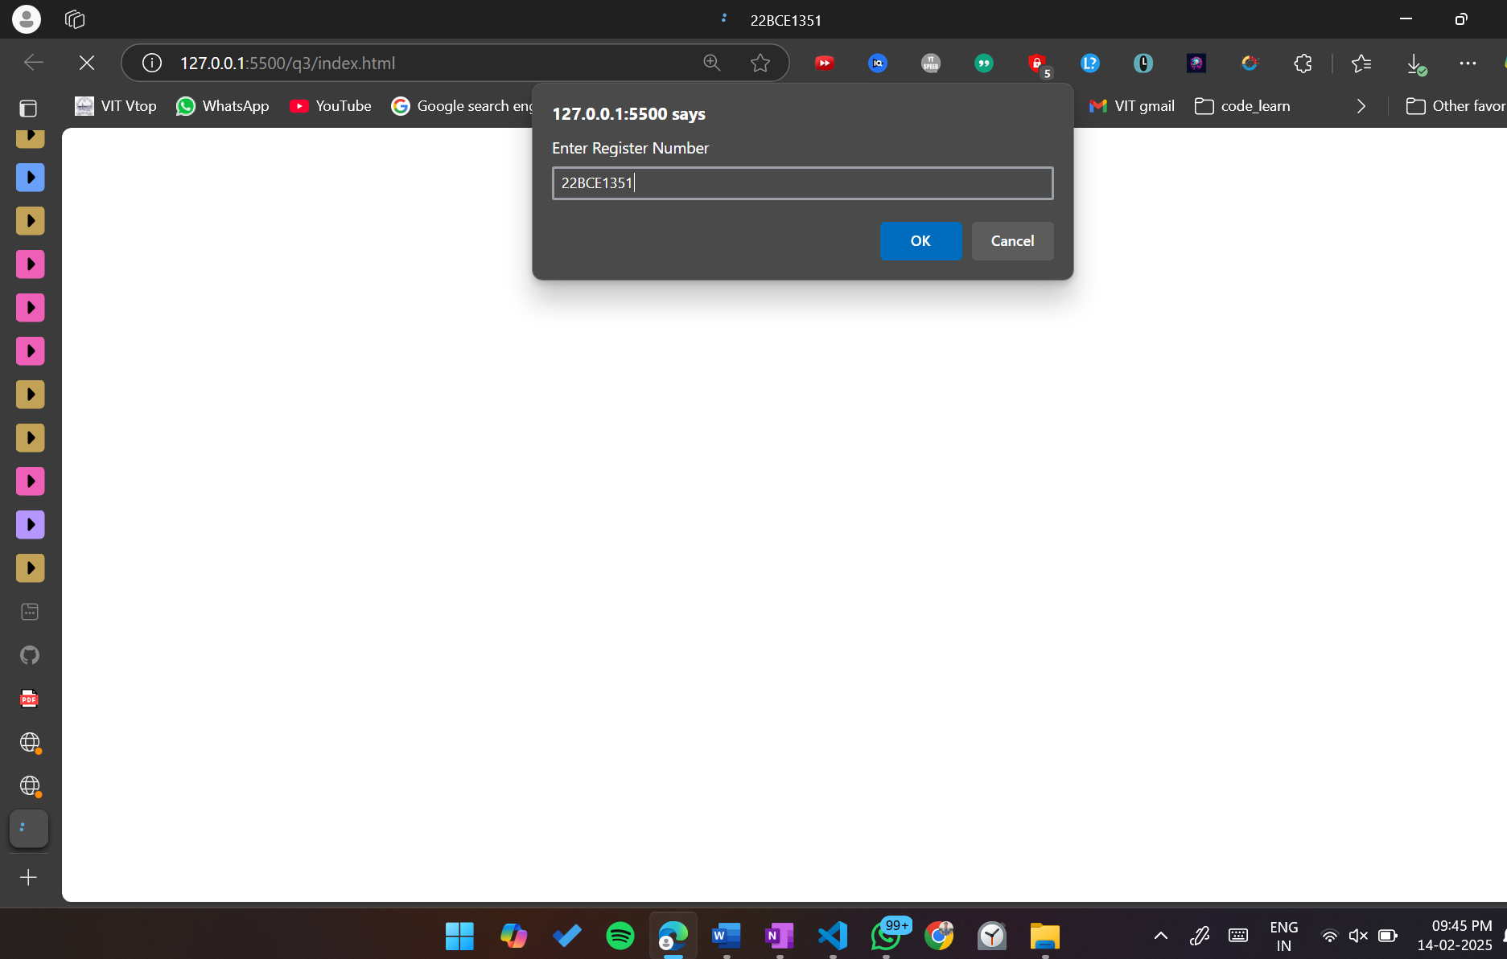

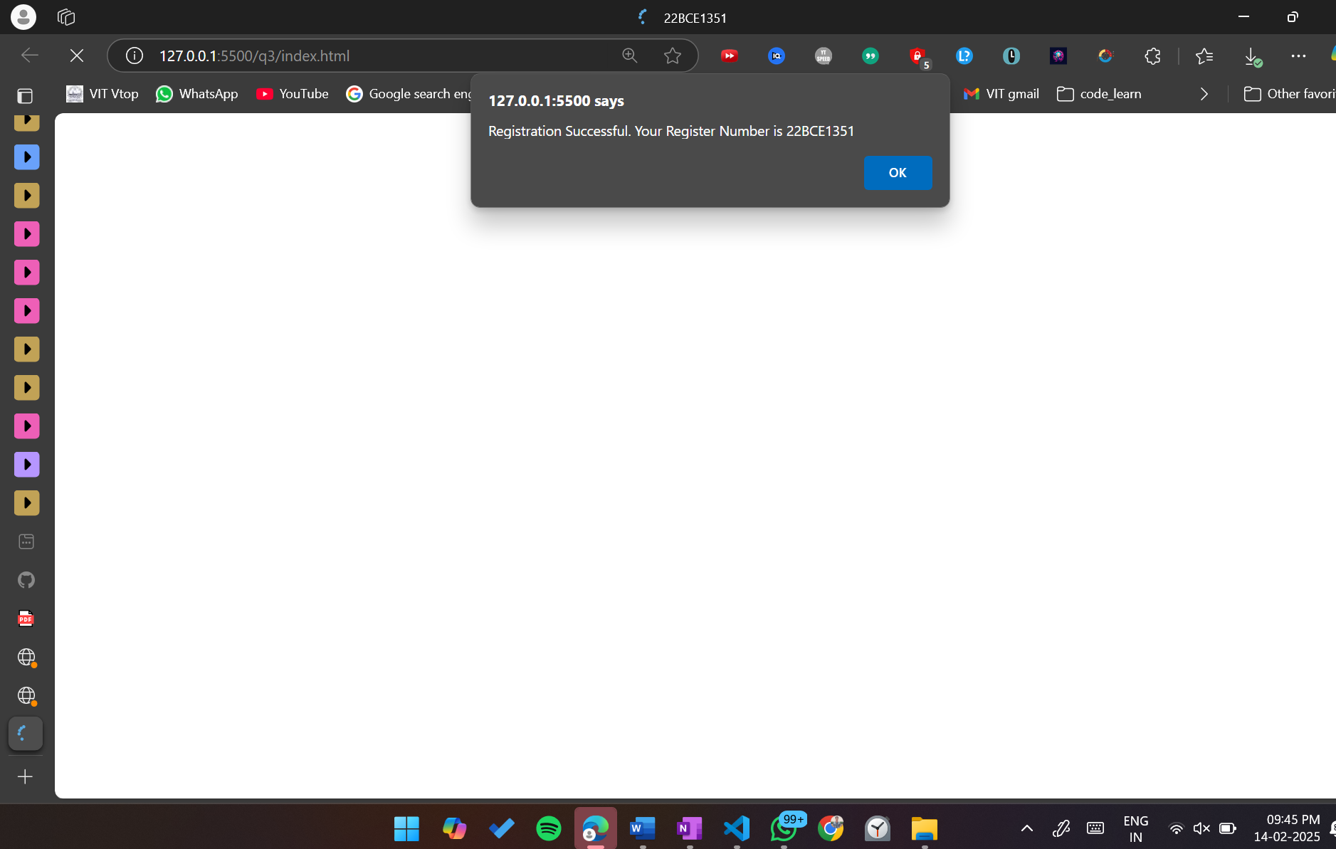

<!DOCTYPE html>

<html lang="en">

<head>

    <meta charset="UTF-8">

    <meta name="viewport" content="width=device-width, initial-scale=1.0">

    <title>22BCE1351</title>

</head>

<body>

    <script>

        let isStudent = confirm("Are you a student? Click 'OK' for Yes and 'Cancel' for No");

        if(isStudent){

            let regNum = prompt("Enter Register Number");

            if(regNum){

                alert("Registration Successful. Your Register Number is " + regNum);

            }else{

                alert("Enter Valid Registration Number");

            }

        }

    </script>

</body>

</html>



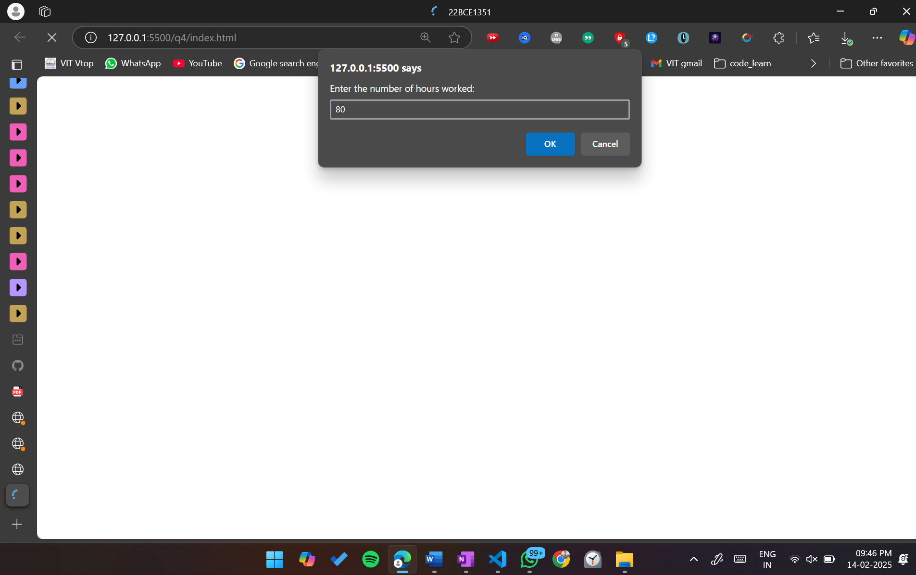

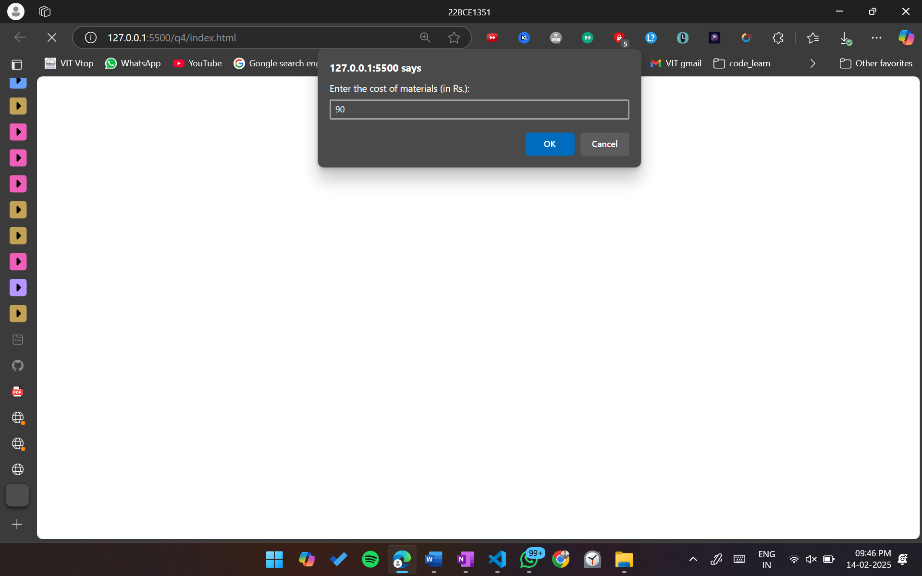

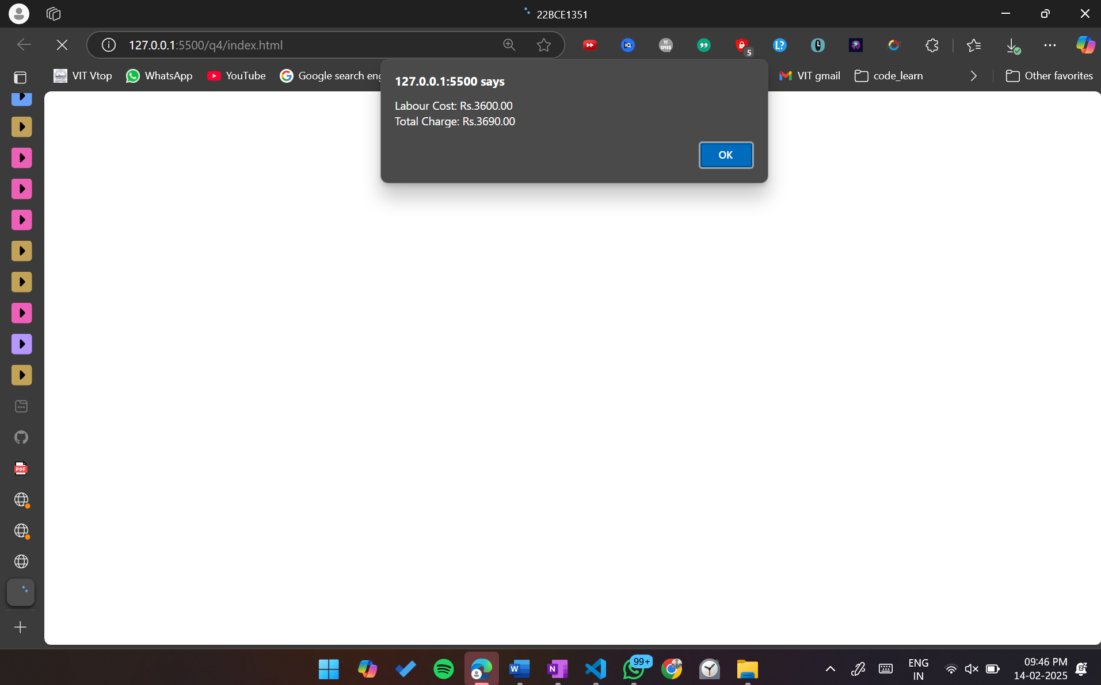

<!DOCTYPE html>

<html lang="en">

<head>

    <meta charset="UTF-8">

    <meta name="viewport" content="width=device-width, initial-scale=1.0">

    <title>22BCE1351</title>

</head>

<body>

    <script>

        function calculateServiceCharge() {

            const ratePerHour = 45;

            let hoursWorked = parseFloat(prompt("Enter the number of hours worked:"));

            let costOfMaterials = parseFloat(prompt("Enter the cost of materials (in Rs.):"));

            if (hoursWorked < 0 || costOfMaterials < 0) {

                alert("Please enter valid numbers for hours worked and cost of materials.");

                return;

            }

            let labourCost = ratePerHour \* hoursWorked;

            let totalCharge = labourCost + costOfMaterials;

            alert(`Labour Cost: Rs.${labourCost.toFixed(2)}\nTotal Charge: Rs.${totalCharge.toFixed(2)}`);

        }

        calculateServiceCharge();

    </script>

</body>

</html>

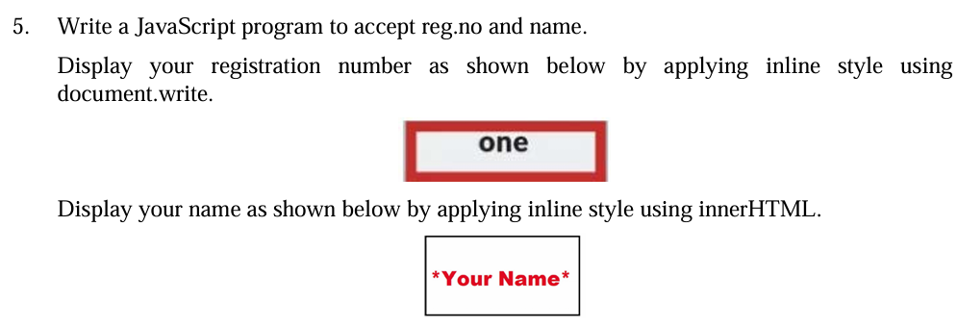

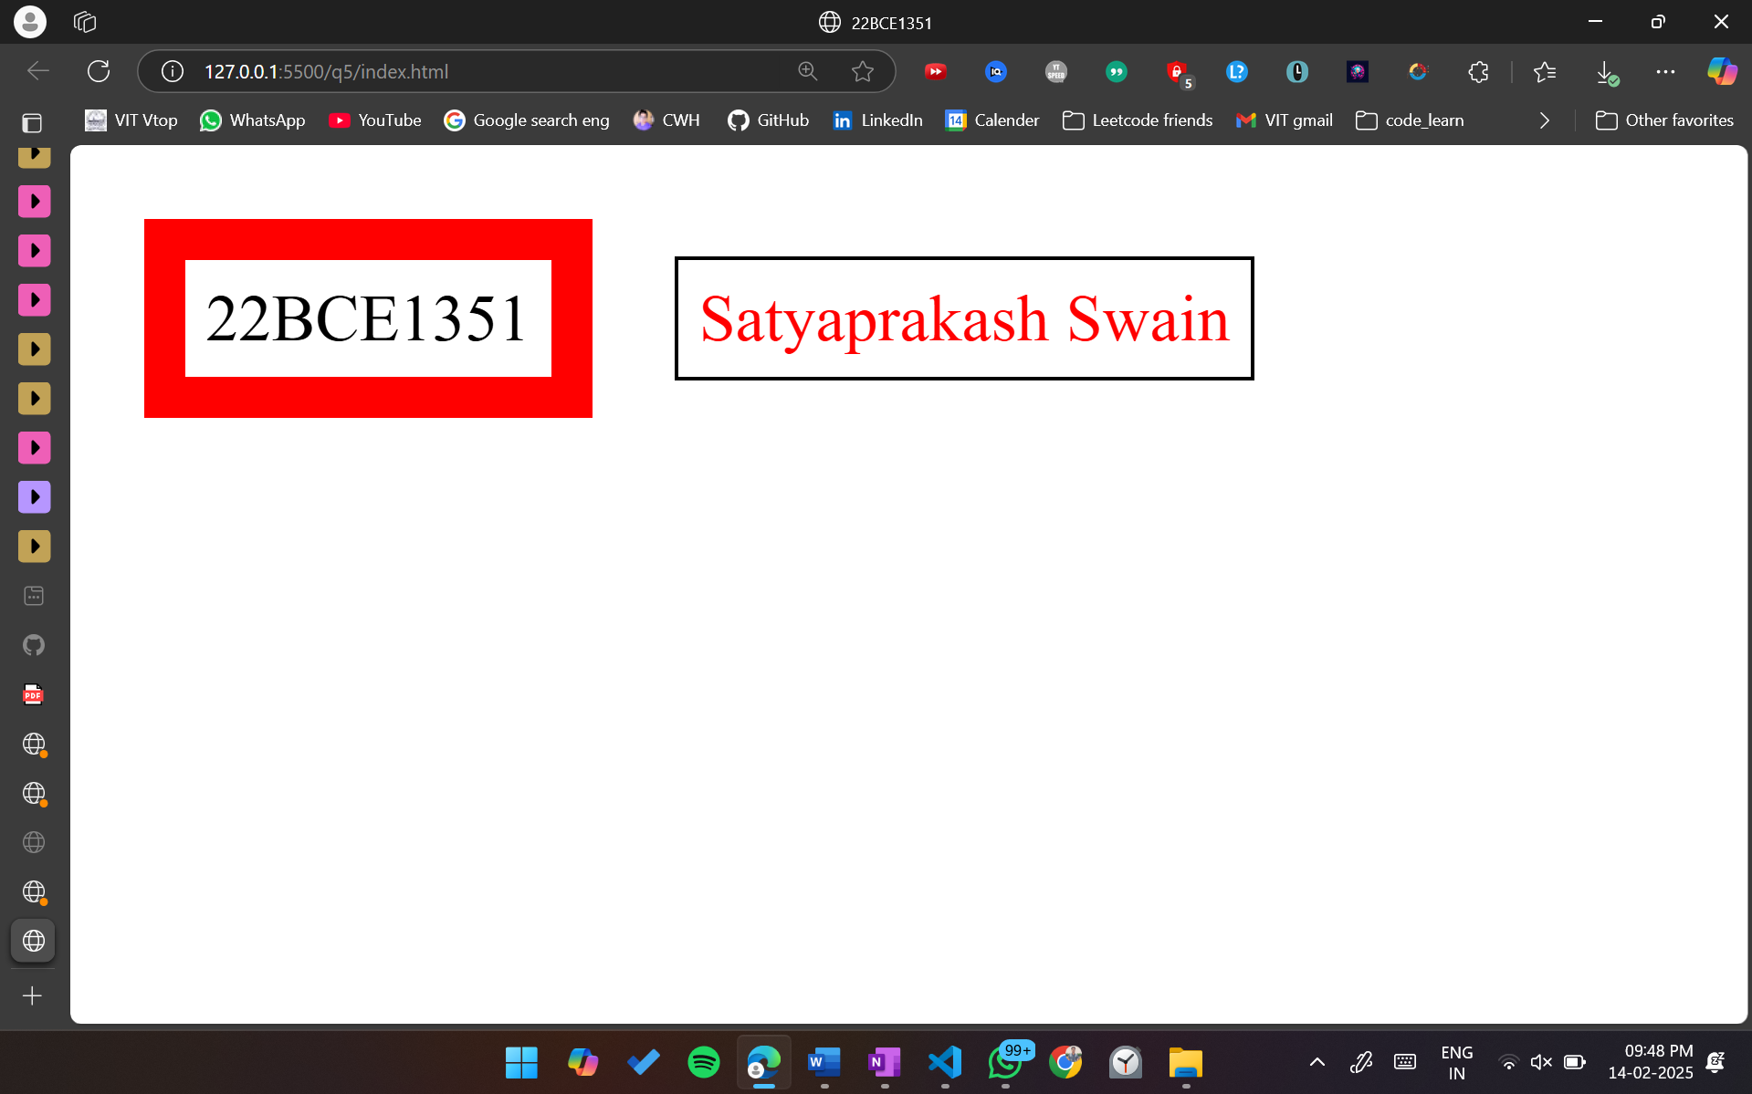

<!DOCTYPE html>

<html lang="en">

<head>

    <meta charset="UTF-8">

    <meta name="viewport" content="width=device-width, initial-scale=1.0">

    <title>22BCE1351</title>

</head>

<body>

    <script>

        function displayRegistrationNumber(regNo) {

            document.write('<span style="border: 10px solid red; display: inline-block; padding: 5px; margin: 10px;">' + regNo + '</span>');

        }

        function displayName(name) {

            const nameElement = document.createElement('span');

            nameElement.style.border = '1px solid black';

            nameElement.style.display = 'inline-block';

            nameElement.style.padding = '5px';

            nameElement.style.margin = '10px';

            nameElement.style.color = 'red';

            nameElement.innerHTML =  name;

            document.body.appendChild(nameElement);

        }

        const regNo = "22BCE1351";

        const name = "Satyaprakash Swain";

        displayRegistrationNumber(regNo);

        displayName(name);

    </script>

</body>

</html>

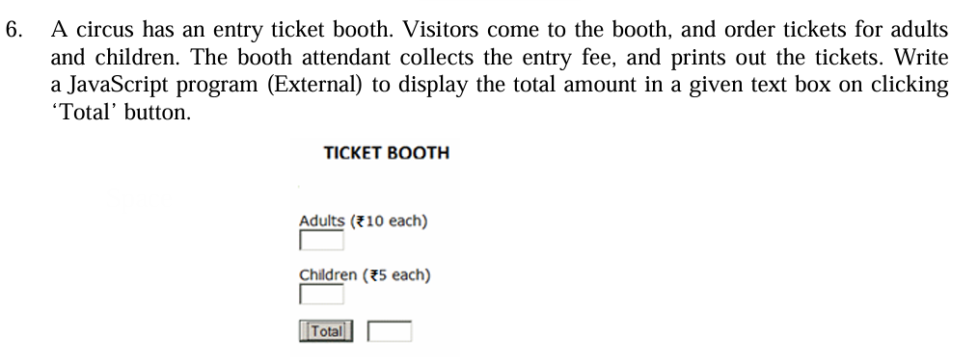

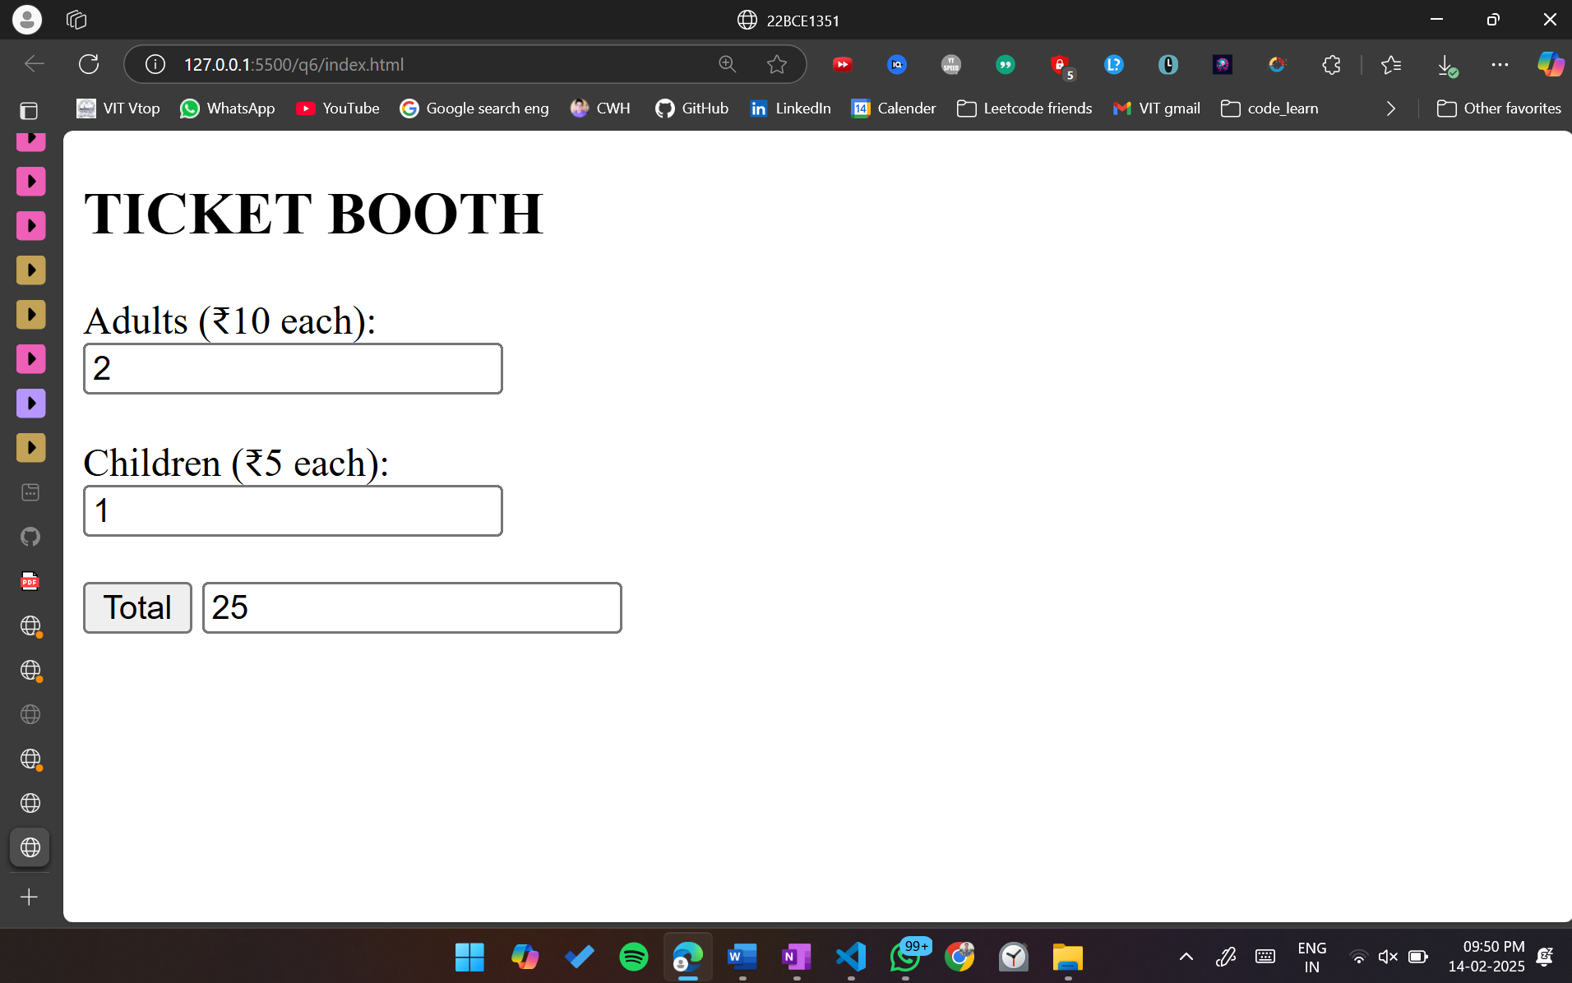

Html

<!DOCTYPE html>

<html lang="en">

<head>

    <meta charset="UTF-8">

    <meta name="viewport" content="width=device-width, initial-scale=1.0">

    <title>22BCE1351</title>

    <script src="script.js"></script>

</head>

<body>

    <h2>TICKET BOOTH</h2>

    <label for="adults">Adults (₹10 each):</label><br>

    <input type="number" name="adults" id="adults" >

    <br>

    <br>

    <label for="children">Children (₹5 each):</label><br>

    <input type="number" name="children" id="children">

    <br>

    <br>

    <button onclick="calcTotal()">Total</button>

    <input type="number" id="total">

</body>

</html>

Js

function calcTotal(){

    let adultPrice = 10;

    let childrenPrice = 5;

    let adultTickets = document.getElementById("adults").value || 0;

    let childTickets = document.getElementById("children").value || 0;

    let totalPrice = adultPrice\*adultTickets + childrenPrice\*childTickets;

    let totalField = document.getElementById("total");

    totalField.value = totalPrice;

}

